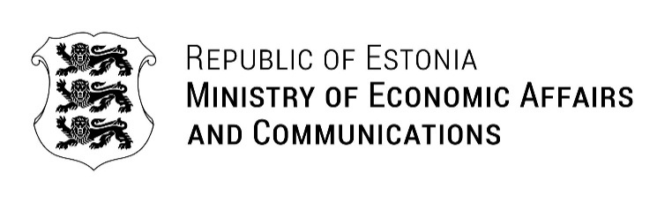
Ms Bahar Muradova  State Committee for Family, Women and Children Affairs of the Republic of Azerbaijan  office@family.gov.az  Ü. Hacıbəyli 80, Government House, Gate IV in Baku, Azerbaijan | Your Ref 20.05.2026 No 1.4-2/1318-1  Our Ref 26.06.2026 No 6-2/1819-2
Nomination of Dr Elgun Safarov to the Committee on the Elimination of Discrimination against Women

Dear Ms Bahar Muradova

I have the honour to acknowledge receipt of your letter concerning the nomination of Dr Elgun Safarov for re-election to the United Nations Committee on the Elimination of Discrimination against Women for the term 2027–2030.

Please accept our apologies for the delay in responding. The letter was initially addressed to Ms Karmen Joller, Minister of Social Affairs, whose portfolio does not include equality policy, and was subsequently forwarded to the Ministry of Economic Affairs and Communications, which is responsible for this area. The intervening public holidays in Estonia also contributed to the delay.

Estonia attaches great importance to the work of the Committee and to the effective implementation of the Convention on the Elimination of All Forms of Discrimination against Women. We appreciate the information provided regarding Dr Safarov’s professional background and experience, as well as the curriculum vitae enclosed with your letter.

Dr Safarov’s candidature, together with the other candidatures submitted for membership of the Committee, will be duly considered in accordance with Estonia’s established procedures and taking into account the qualifications, expertise and experience of all candidates.

Please accept, Your Excellency, the assurances of my highest consideration.

With best regards,

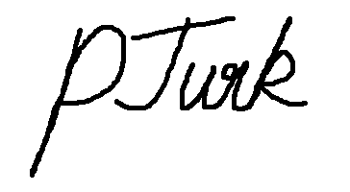

Pirjo Turk
Director of Equality Policies Department

